Meta title: Game Development Company | Custom Gaming Solutions

Meta Description: Top game development company offering custom ar/vr game development, metaverse, unreal engine, unity, web3 & custom gaming solutions across all cross-platforms.

URL: https://www.heybuddy.co.in/services/game-development

Game Development Company in India

Stop building clones. We engineer high-retention, revenue-first gaming ecosystems for the 2026 market. Whether you need Full-Cycle Game Development to bring a new vision to life or Seamless Co-Development to scale your game studios technical firepower, we deliver production-ready excellence.
- End-to-End Game Development
- Cross-Platform Expertise
- Post-Launch Support & Live Ops
Get Your Free Project Roadmap

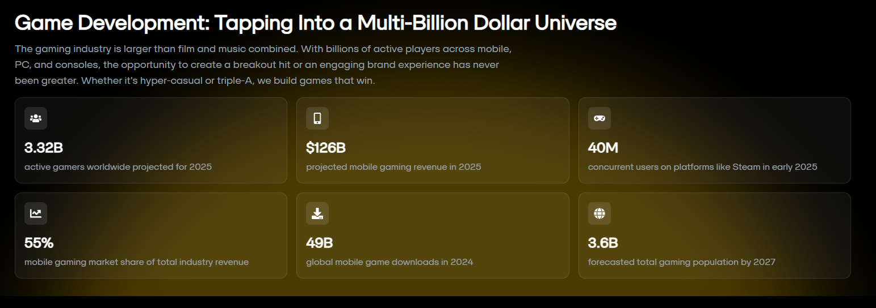

Our Comprehensive End-to-End Game Development Services

At the intersection of high-end engineering and artistic vision, we provide comprehensive game development solutions. We don't just build games; we engineer high-performance digital ecosystems designed for the future gaming landscape.

1. Mobile Game Development Services
We develop outstanding mobile games for iOS and Android, reaching a global audience through seamless cross-platform skills. From hyper-casual titles to complex mid-core RPGs, we optimize for performance and retention.
- Platform Optimization
- 5G Connectivity Integration
- In-App Purchase Architectures
- Social Hub Integration
- LiveOps & Analytics
- Push Notification Systems

2. Unreal Engine Game Development Services
Utilizing Unreal Engine 5.5, we push the limits of visual fidelity. We specialize in high-end graphics and complex physics to create cinematic experiences that blur the line between reality and digital art.
- Lumen & Nanite Implementation
- Blueprint & C++ Programming
- Photorealistic Environments
- Advanced Physics Simulations
- High-Density Geometry
- Cinematic Sequencing

3. Unity Game Development Services
As experts in Unity 6, we offer versatile development for 2D, 3D, and AR/VR projects. We leverage Unity’s universal reach to ensure your game performs flawlessly across mobile, web, and desktop.
- Universal Render Pipeline (URP)
- Cross-Platform Deployment
- Rapid Prototyping
- Custom Shader Development
- Asset Store Integration
- Multiplayer Networking

4. Metaverse Game Development Services
We build persistent virtual worlds that serve as social and economic hubs. Our metaverse solutions combine spatial computing with digital identity to create the next generation of social gaming.
- Persistent World Building
- Digital Avatar Systems
- Social Hub Creation
- Virtual Real Estate
- Agentic AI NPCs
- Cross-World Interoperability

5. Web3 Game Development Services
As a leading Web3 game development company, we integrate blockchain technology to facilitate decentralized gameplay. We focus on player-driven economies and secure, transparent digital ownership.
- Smart Contract Integration
- Decentralized Economies
- Play-to-Earn (P2E) Mechanics
- Wallet Connectivity
- DAO Governance Tools
- On-Chain Logic

6. AR/VR Game Development Services
We push the boundaries with AR/VR technology, crafting unforgettable experiences for hardware like Apple Vision Pro and Meta Quest. We redefine interactive entertainment through spatial immersion.
- Spatial Mapping
- Motion Tracking & Haptics
- 360° Environment Design
- Gesture Recognition
- Mixed Reality (MR) Overlays
- VR Performance Optimization

7. Console Game Development Services
We bring your vision to the "big screen" by developing native titles for PlayStation 5 Pro, Xbox Series X, and Nintendo Switch. Our team manages the rigorous technical requirements and certification standards necessary for a successful console launch.
- TRC/XR Compliance
- Hardware Haptics Integration
- Controller-First UI/UX
- Split-Screen Optimization
- Console-Specific Shaders
- First-Party Store Integration

8. PC Game Development Services
Our team delivers captivating games for Windows and MacOS, ensuring "Ultra" performance and a fantastic gaming environment for desktop players. We specialize in building scalable architectures that run smoothly on everything from the Steam Deck to high-end enthusiast rigs.
- Deep Hardware Scalability
- Steam/Epic Store Integration
- Modding Support Infrastructure
- Advanced Telemetry Systems
- Peripheral Customization (KBM)
- Ultra-Wide Screen Support

9. Casino Game Development Services
We build high-stakes, visually stunning casino ecosystems. Our focus is on creating immersive, "Vegas-style" experiences that prioritize mathematical precision, global security standards, and high-velocity gameplay.
- Certified RNG Algorithms
- Multi-Slot Math Models
- Visual Jackpots & Effects
- Global Payment Gateways
- Bonus Game Mechanics
- Regulatory Compliance (GLI)

10. Rummy Game Development Services
We develop secure, high-concurrency Rummy platforms designed for millions of real-time players. Our architecture is built to handle rapid card logic, fair play monitoring, and seamless tournament transitions without latency.
- Anti-Fraud & Collision Detection
- Real-Time Turn Management
- Tournament Lobby Scaling
- Multi-Table Functionality
- Player Lifecycle Analytics
- Instant Withdrawal Systems

Game app Development Solutions
As a leading AI development company, we move beyond basic genre definitions to engineer high-retention, market-ready digital experiences. Our game app development solutions focus on technical reliability, player lifetime value (LTV), and seamless performance across every major platform.

Action & Role-Playing Games (RPGs)
We build sprawling worlds with deep progression systems. Our focus is on responsive combat mechanics, complex character skill trees, and rich narratives that keep players engaged for the long term.

Strategy & Simulation Games
Replicating real-world experiences requires precision. We design intuitive UI/UX for deep systems, balancing complex economy loops and realistic scenarios ranging from city-building to business management.

Sports & Racing Games
We deliver high-adrenaline experiences focused on physics-based realism. Whether it’s field sports or high-speed racing, we ensure precision handling and competitive multiplayer environments.

Puzzle & Board Games
We transform traditional social interactions into modern digital staples. From classic chess and ludo to innovative physics-puzzles, we focus on social connectivity and addictive, short-session gameplay.

Casino & Real Money Gaming (RMG)
We develop secure, feature-rich platforms for slots, poker, and rummy. We prioritize mathematical precision, certified RNG integration, and robust anti-fraud layers for regulated gaming markets.

Single & Multiplayer Games
We offer scalable single and multiplayer game development solutions for real-time and turn-based gameplay. Our expertise includes multiplayer networking, matchmaking systems, cloud integration, and secure backend architectures, ensuring smooth gameplay and seamless player interactions.

Play-to-Earn (P2E) Games
We offer Play-to-Earn game solutions that integrate blockchain technology to enable real-world value generation. By combining NFTs, token economies, and secure marketplaces, our solutions empower players to earn, trade, and grow digital assets within engaging game ecosystems.

Move-to-Earn Games
Our Move-to-Earn solutions merge gaming with real-world activity. By converting physical movements like walking or running into in-game rewards, tokens, or NFTs, we create experiences that encourage healthy lifestyles while delivering meaningful player incentives.

Adventure Game Solutions
Our adventure game solutions focus on narrative-driven gameplay combined with exploration and puzzles. We design intuitive user experiences, cinematic environments, and interactive storylines that guide players through exciting journeys filled with discovery and challenge.

Success Stories Showcasing our Game Development Studio

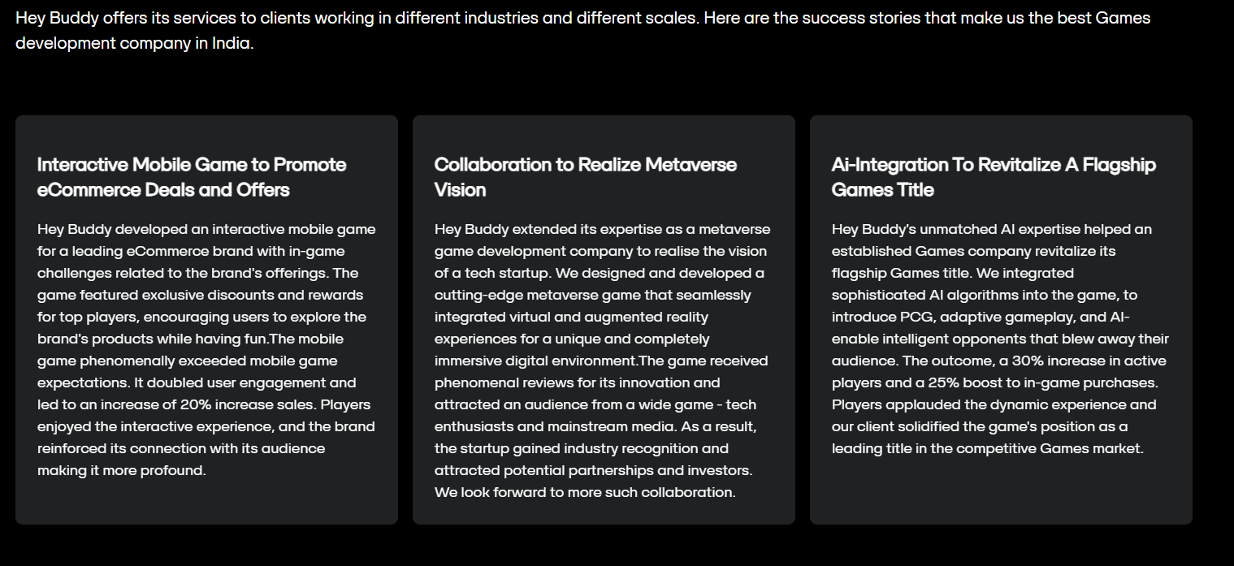

Cross-Platform Game Development: Building Ecosystems, Not Just Apps
We provide end-to-end cross-platform game development that erases the boundaries between hardware.

Mobile Game Development
We develop outstanding mobile games for iOS and Android. Our cross-platform expertise allows us to reach a global audience seamlessly, combining high-performance playability with deep social integration.

Console Game Development
We bring your vision to the "big screen" with native builds for PS5 Pro, Xbox Series X, and Nintendo Switch. Our team navigates the complex certification processes to ensure a Day-1 global launch.

AR / VR Game Development
We push the boundaries with AR/VR technology, crafting unforgettable, immersive experiences that redefine interactive entertainment for the next generation of spatial computing.

PC Game Development
Our team delivers captivating games for Windows and MacOS, ensuring "Ultra" performance and a fantastic gaming environment tailored specifically for desktop players.

Why Game Studios choose our Game Development Company
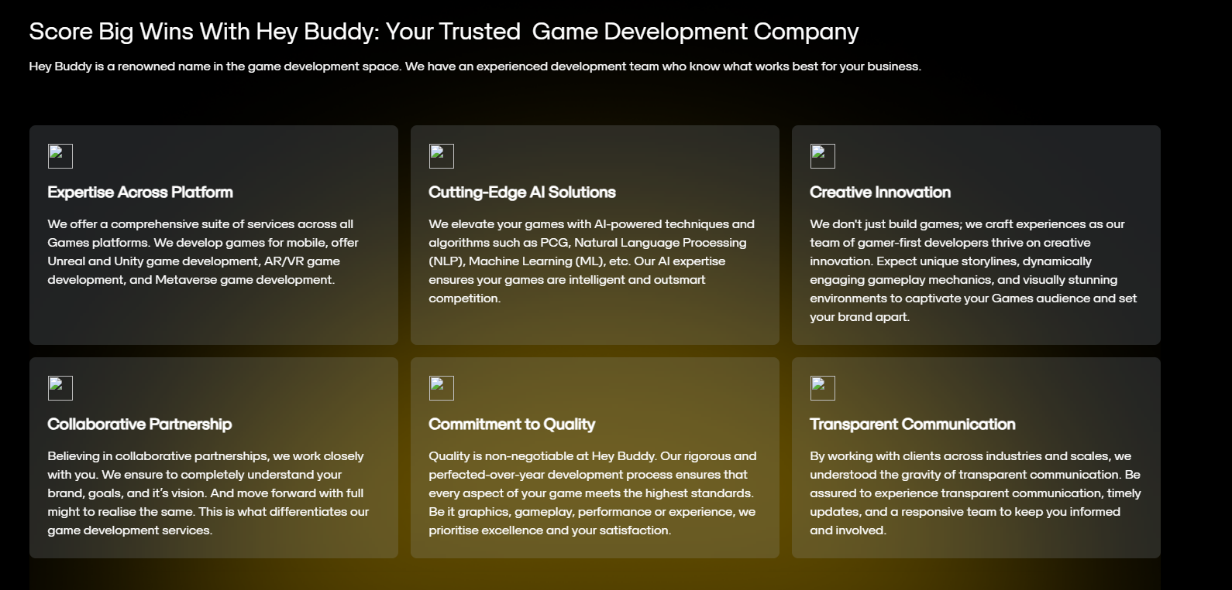
custom ar/vr game development (first box)
best game developers (third box)

Technology Stack for our Game Development Studio

1. Core Game Engines
- Unreal Engine 5.5
- Unity 6
- Blockchain & Web3

2. Backend
- C#
- Node.js
- Python
- Java
- PHP
- Ruby
- .Net

3. Database Management
- SQL Server
- MySQL
- PostgreSQL
- MongoDB
- SQLite
- Firebase

4. Cloud & Infrastructure
- Amazon Web Services (AWS)
- Google Cloud Platform (GCP)
- Microsoft Azure

5. DevOps
- Jenkins
- Azure DevOps
- AWS DevOps
- Docker
- Kubernetes

6. CRM (Player Management)
- Salesforce
- Microsoft Dynamics 365
- HubSpot
- Zoho
- Sugar CRM

Our Game Development Process: Precision in Progress

1. Discovery & Strategic Planning
Before a single line of code is written, we align your vision with market reality.
- Market Analysis: Identifying genre trends, competitor gaps, and player behavior for 2026.
- Monetization Strategy: Planning IAPs, Battle Passes, or Ad-models early to ensure a sustainable economy.
- Technical Feasibility: Selecting the right engine (Unreal 5.5 vs. Unity 6) based on target platforms (Mobile, PC, Console, or Cloud).

2. Pre-Production & The GDD
This is the "Blueprint" phase where we eliminate future risks.
- Game Design Document (GDD): A living document detailing every mechanic, story arc, and UI flow.
- Concept Art & Wireframes: Visualizing characters and environments to lock in the art direction.
- Technical Architecture: Designing the backend for multiplayer concurrency and data security.

3. Rapid Prototyping (Greyboxing)
We verify the "Fun Factor" early.
- Core Mechanic Testing: Building a bare-bones version to test movement, combat, or puzzles.
- Vertical Slice: A polished 5-minute segment of the game used for stakeholder approval or investor pitches.

4. Asset Production (Visual & Audio)
Where the game gets its soul.
- Modeling & Texturing: High-fidelity 3D assets optimized for performance (using Nanite/Lumen for Unreal).
- Animation & Rigging: Smooth, lifelike character movements and VFX.
- Spatial Audio: Professional soundscapes and voice-overs that create total player immersion.

5. Core Development & System Logic
The busiest phase of the pipeline where our engineers take over.
- Gameplay Programming: Coding the physics, AI behaviors, and player controls.
- Multiplayer & Backend: Integrating real-time networking, leaderboards, and secure cloud storage.
- AI-Driven NPCs: Implementing Agentic AI for smarter, non-scripted NPC interactions.

6. Rigorous QA & Stress Testing
We hunt bugs so your players don't have to.
- Functional & Regression Testing: Checking every feature against the GDD.
- Performance Benchmarking: Testing on 50+ device configurations to ensure smooth frame rates.
- Beta Testing: Opening the game to external users for real-world balance and feedback.

7. Deployment & Certification
A seamless launch across all chosen storefronts.
- Store Optimization (ASO/SEO): Managing submissions for Steam, App Store, Play Store, and Consoles.
- Server Scaling: Ensuring backend stability for Day-1 peak traffic.

8. LiveOps & Post-Launch Support
The game is a living product that evolves daily.
- Continuous Updates: Regular patches, seasonal events, and new level drops to maintain retention.
- Data Analytics: Monitoring player behavior to optimize monetization and difficulty curves.
- 24/7 Technical Support: Proactive monitoring to ensure zero downtime for your community.

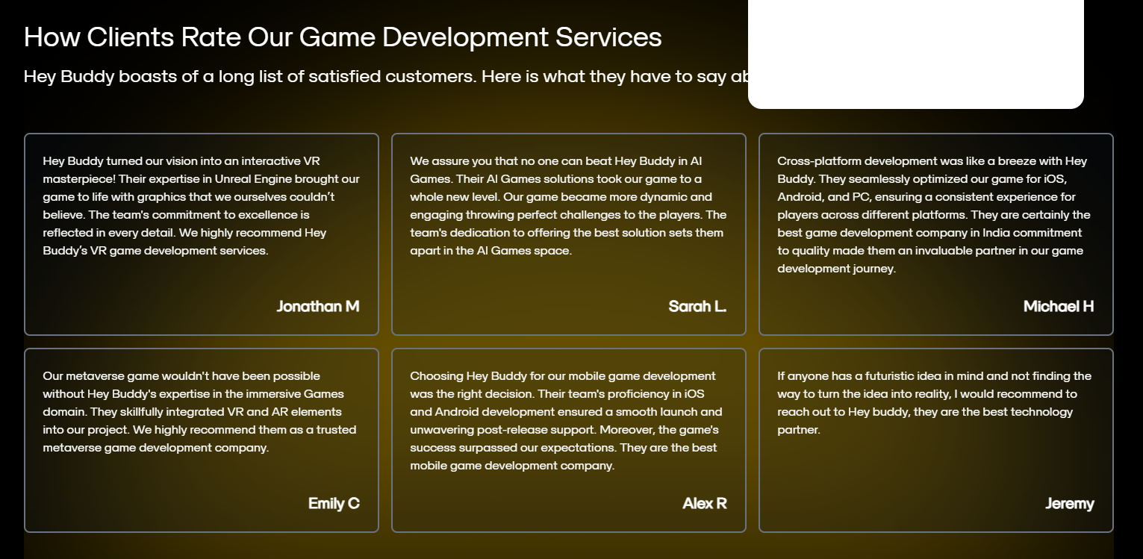
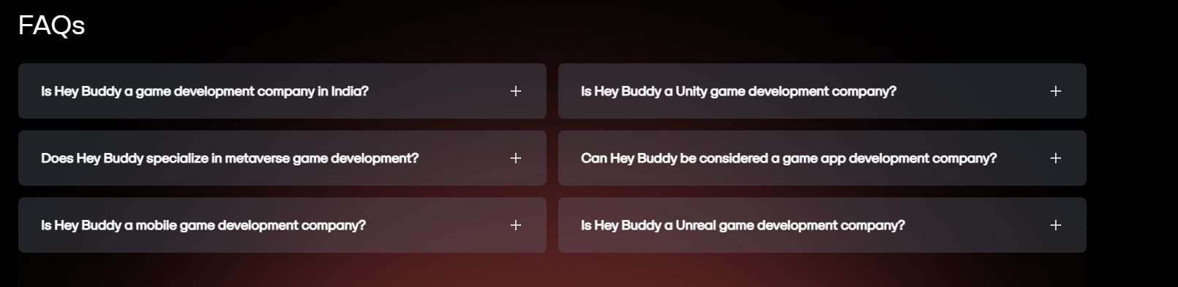

Custom metaverse

